Basics of functions

1) Write a program with two functions:

a. The first function should display diskspace usage in human readable form.

(Hint: df -h)

b. The second function should display filesystem usage in human readable form.

(Hint: du -h)

Function.sh

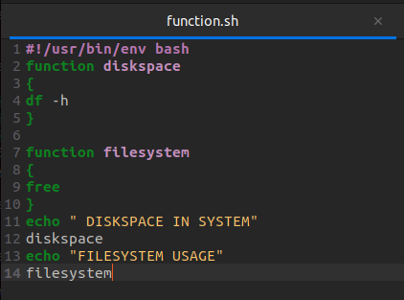

Terminal

